Name

Mathematics Stage 5 Core
Algebraic Fractions

Book 1 |  | Version: 261002  Feedback:  https://MrDingMaths.com
Contents
Syllabus Content 2
Learning Intention 3

Syllabus Content
MA5-ALG-C-01 simplifies algebraic fractions with numerical denominators and expands algebraic expressions
Apply the 4 operations to simplify algebraic fractions with numerical denominators
- Simplify expressions that involve algebraic fractions with numerical denominators

Algebraic Fraction Addition: Same Denominator

- Review
- Simplify fractions
- $\frac{6}{12}$ | - $\frac{18}{24}$ | - $\frac{9}{24}$ | - $\frac{16}{16}$
- $\frac{14}{7}$ | - $\frac{12}{18}$ | - $\frac{8}{56}$ | - $\frac{9}{27}$

- Add and subtract fractions
- $\frac{5}{7}+\frac{1}{7}$ | - $\frac{2}{15}+\frac{8}{15}+\frac{1}{15}$ | - $\frac{6}{7}-\frac{2}{7}-\frac{4}{7}$

- Simplify expressions by combining like terms.
- $7a+12a$ | - $16u-3u$ | - $3+b$
- $2x+3+5x$ | - $7ab+b$ | - $-4a+5a-7a$

- Adding and Subtracting Algebraic Fractions
Algebraic fractions have algebraic expressions in their numerator or denominator.
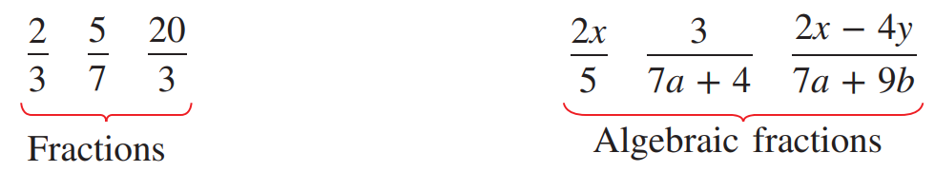

The denominators must be the same before adding or subtracting algebraic fractions.\
Adding fractions  $$\frac{a}{n}+\frac{b}{n}=\frac{a+b}{n}$$ | Subtracting fractions  $$\frac{a}{n}-\frac{b}{n}=\frac{a-b}{n}$$

- Example Add/subtract algebraic fractions with the same denominator
$$\frac{5x}{13}+\frac{3x}{13}$$  $$=\frac{5x+3x}{13}=\frac{8x}{13}$$ | $$\frac{5x}{13}-\frac{3y}{13}$$  $$=\frac{5x-3y}{13}$$

- Guided Practice
Simplify these expressions.
- $\frac{x}{1}+\frac{2x}{1}$  $$3x$$ | - $\frac{x}{4}+\frac{2x}{4}$  $$\frac{3x}{4}$$ | - $\frac{a}{3}+\frac{2a}{3}$  $$a$$
- $\frac{3y}{5}-\frac{y}{5}$  $$\frac{2y}{5}$$ | - $\frac{4p}{6}-\frac{p}{6}$  $$\frac{p}{2}$$ | - $\frac{2y}{15}+\frac{3y}{15}$  $$\frac{y}{3}$$

- Key Ideas
- When adding or subtracting fractions with the same denominator, we add or subtract the …………………… and keep the …………………… the same.

Foundation
- Add and subtract these fractions.
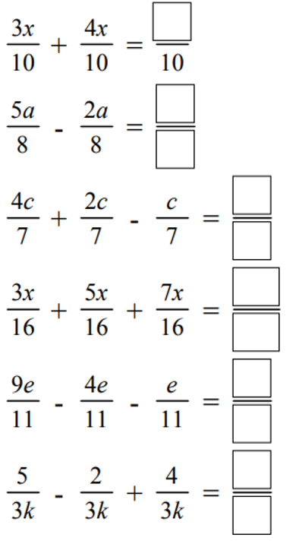  $$\frac{7x}{10}$$ | $$\frac{3a}{8}$$ | $$\frac{5c}{7}$$
- $\frac{4k}{3}+\frac{k}{3}$  $$\frac{5k}{3}$$ | - $\frac{3y}{5}-\frac{y}{5}$  $$\frac{2y}{5}$$ | - $\frac{7p}{13}-\frac{2p}{13}$  $$\frac{5p}{13}$$
- $\frac{10r}{7}-\frac{2r}{7}$  $$\frac{8r}{7}$$ | - $\frac{8q}{5}-\frac{2q}{5}$  $$\frac{6q}{5}$$ | - $\frac{8q+5}{11}+\frac{2q}{11}$  $$\frac{6q+5}{11}$$
$$\frac{15x}{16}$$ | $$\frac{4e}{11}$$ | $$\frac{8}{3k}$$

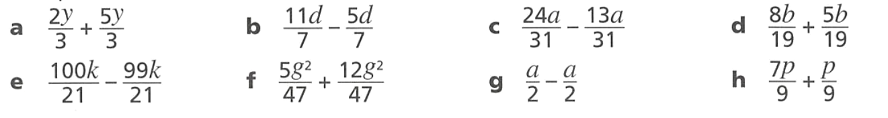
- Add and subtract these fractions.
$$\frac{7y}{3}$$ | $$\frac{6d}{7}$$ | $$\frac{11a}{31}$$ | $$\frac{13b}{19}$$
$$\frac{k}{21}$$ | $$\frac{17g^{2}}{47}$$ | $$0$$ | $$\frac{8p}{9}$$

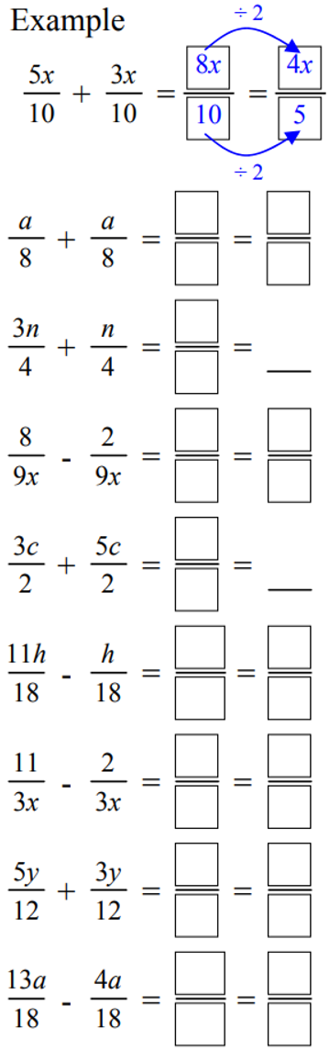
- Add and subtract these fractions, then simplify the result.
 | $$\frac{a}{4}$$ | $$n$$
$$\frac{2}{3x}$$ | $$4c$$ | $$\frac{5h}{9}$$
$$\frac{3}{x}$$ | $$\frac{2y}{3}$$ | $$\frac{a}{2}$$

Algebraic Fraction Addition: Different Denominator

- Review
- Add and subtract fractions
- $\frac{5}{7}+\frac{1}{7}$ | - $\frac{2}{15}+\frac{8}{15}+\frac{1}{15}$ | - $\frac{6}{7}-\frac{2}{7}-\frac{4}{7}$
- $1-$ $\frac{1}{4}$ | - $1-$ $\frac{3}{5}$ | - $2-$ $\frac{6}{7}$

- Find the lowest common denominator (LCD) of these fractions.
- $\frac{}{3}$ and $\frac{}{5}$ | - $\frac{}{4}$ and $\frac{}{5}$ | - $\frac{}{7}$ and $\frac{}{6}$ | - $\frac{}{3}$ and $\frac{}{6}$
- $\frac{}{3}$ and $\frac{}{5}$ | - $\frac{}{4}$ and $\frac{}{5}$ | - $\frac{}{12}$ and $\frac{}{6}$ | - $\frac{}{10}$ and $\frac{}{20}$

- Find the missing number to make these fractions equivalent.
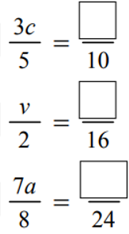 |  |  | 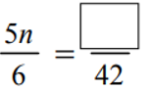

- Add and subtract these fractions.
- $\frac{7}{20}+\frac{5}{10}$ | - $\frac{7}{10}-\frac{2}{5}$ | - $\frac{11}{12}-\frac{1}{3}-\frac{1}{4}$
- $\frac{1}{7}+\frac{2}{5}$ | - $\frac{1}{4}+\frac{2}{3}$ | - $\frac{3}{7}-\frac{2}{9}$

- Adding and Subtracting Algebraic Fractions (Different Denominator)
- Rewrite the fractions with the lowest common multiple of the denominators.
- Add or subtract the numerators.

- Example Add/subtract algebraic fractions with different denominators
$$\frac{4x}{3}-\frac{x}{6}$$  1. Same denominators $\frac{}{6}$ $-$ $\frac{}{6}$  $\frac{8x}{6}$ $-$ $\frac{x}{6}$  2. Subtract numerators $\frac{7x}{6}$ | $$\frac{5x}{3}+\frac{11x}{4}$$  1. Same denominators $\frac{}{12}$ $+$ $\frac{}{12}$  $\frac{20x}{12}$ $+$ $\frac{33x}{12}$  2. Add numerators $\frac{53x}{12}$

- Guided Practice
Simplify
- $\frac{y}{4}+\frac{y}{2}$  $$=\frac{y}{4}+\frac{}{4}$$  $=$  $$\frac{3y}{4}$$ | - $\frac{3x}{6}-\frac{x}{2}$  $$0$$
- $\frac{y}{3}-\frac{a}{4}$  $$\frac{4y-3a}{12}$$ | - $\frac{x}{5}+\frac{2x}{3}$  $$\frac{13x}{15}$$
- $3x+$ $\frac{x}{2}$  $$\frac{7x}{2}$$ | - $\frac{4x}{3}+\frac{3x}{10}$  $$\frac{49x}{30}$$

- Key Ideas
- To add or subtract fractions, the ………………… must be the same.
- To make the denominators the same, find the ……………… of the two denominators.

Foundation
- Add and subtract these fractions.
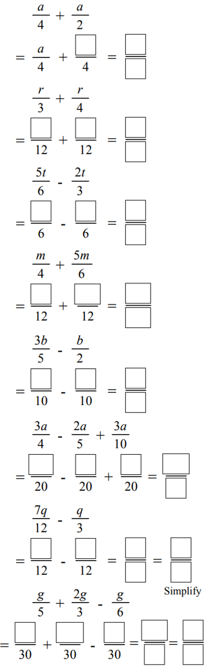  $$\frac{3a}{4}$$ | $$\frac{7r}{12}$$ | $$\frac{t}{6}$$
$$\frac{13m}{12}$$ | $$\frac{13a}{20}$$ | 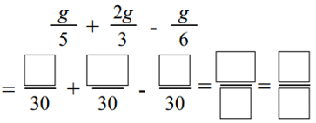  $$\frac{7g}{10}$$

- Complete these simplifications.
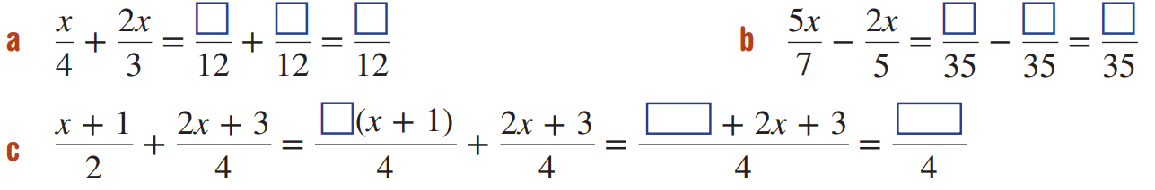  $$\frac{11x}{12}$$ | $$\frac{11x}{35}$$ | $$\frac{4x+5}{4}$$

- Add and subtract these fractions.
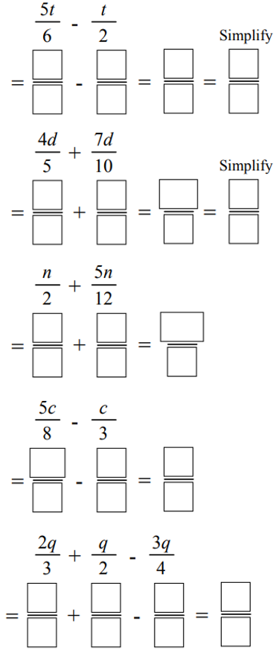  $$\frac{t}{3}$$ | $$\frac{3d}{2}$$ |  | $$\frac{11n}{12}$$
$$\frac{7c}{24}$$ | $$\frac{5q}{12}$$ |  | 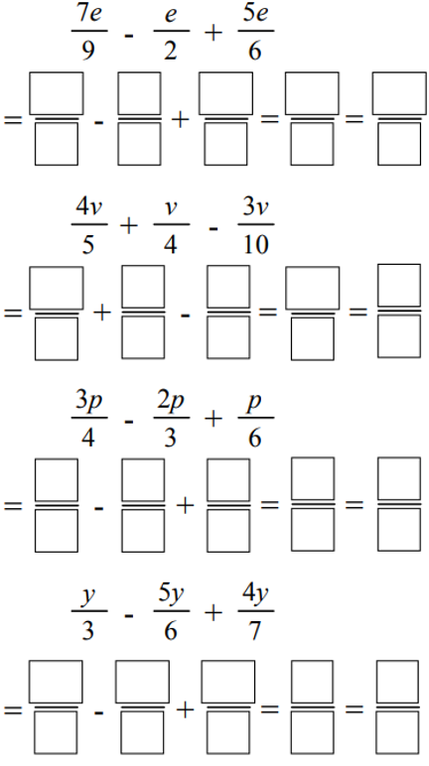  $$\frac{10e}{9}$$
$$\frac{3v}{4}$$ |  | $$\frac{p}{4}$$

Development

- Madeline and Abbie are working out $\frac{11a}{4}-\frac{5a}{2}$

The answer is $\frac{1}{4}a$
The answer is $\frac{a}{4}$

Explain why they are both correct.

$\frac{a}{4}$ is the same as $a÷4=a×$ $\frac{1}{4}$
- Simplify the following. You will need to rewrite the fractions with a common denominator.
- $\frac{p}{2}-\frac{p}{3}$  $$\frac{p}{6}$$ | - $\frac{a}{2}+\frac{a}{3}$  $$\frac{5a}{6}$$ | - $\frac{a}{4}+\frac{a}{5}$  $$\frac{9a}{20}$$ | - $\frac{p}{2}+\frac{p}{5}$  $$\frac{7p}{10}$$
- $\frac{q}{4}+\frac{q}{2}$  $$\frac{3q}{4}$$ | - $\frac{2k}{5}+\frac{3k}{7}$  $$\frac{29k}{35}$$ | - $\frac{2t}{5}-\frac{t}{3}$  $$\frac{t}{15}$$ | - $\frac{9u}{11}-\frac{u}{2}$  $$\frac{7u}{22}$$
- $\frac{8y}{3}-\frac{5y}{6}$  $$\frac{11y}{6}$$ | - $\frac{2m}{5}+\frac{4m}{3}$  $$\frac{26m}{15}$$ | - $\frac{7p}{6}+\frac{2p}{5}$  $$\frac{47p}{30}$$ | - $\frac{x}{4}+\frac{3x}{8}$  $$\frac{5}{8}$$
- $\frac{r}{3}-\frac{r}{2}$  $$-\frac{r}{6}$$ | - $\frac{6u}{7}-\frac{7u}{6}$  $$-\frac{13u}{42}$$ | - $\frac{4h}{9}+\frac{2d}{5}$  $$\frac{38d}{45}$$ | - $\frac{5m}{12}-\frac{3m}{8}$  $$\frac{m}{24}$$

- Simplify the following. Write as a single fraction. Reminder that $4x$ is the same as $\frac{4x}{1}$
- $4x+$ $\frac{x}{3}$  $$\frac{13x}{3}$$ | - $3x+$ $\frac{x}{2}$  $$\frac{7x}{2}$$ | - $\frac{a}{5}+$ $2a$  $$\frac{11x}{5}$$ | - $\frac{8p}{3}-$ $2p$  $$\frac{2p}{3}$$
- $\frac{10u}{3}+\frac{3v}{10}$  $$\frac{100u+9v}{30}$$ | - $\frac{7y}{10}-\frac{2x}{5}$  $$\frac{7y-4x}{10}$$ | - $2t+$ $\frac{7p}{2}$  $$\frac{4t+7p}{2}$$ | - $\frac{x}{3}-$ $y$  $$\frac{x-3y}{3}$$

- Complete each calculation, leaving your answer as a multiple of $π$.
- $π-\frac{π}{3}$  $$\frac{2π}{3}$$ | - $π+\frac{π}{3}$  $$\frac{4π}{3}$$ | - $π+\frac{π}{4}$  $$\frac{5π}{4}$$ | - $π-\frac{π}{4}$  $$\frac{3π}{4}$$
- $π+\frac{π}{6}$  $$\frac{7π}{6}$$ | - $π-\frac{π}{6}$  $$\frac{5π}{6}$$ | - $2π-\frac{π}{3}$  $$\frac{tπ}{3}$$ | - $2π-\frac{π}{4}$  $$\frac{7π}{4}$$
- $2π-\frac{π}{6}$  $$\frac{11π}{6}$$ | - $2π+\frac{π}{3}$  $$\frac{7π}{3}$$ | - $π+\frac{π}{2}$  $$\frac{3π}{2}$$ | - $π+\frac{2π}{3}$  $$\frac{5π}{3}$$
- $π+\frac{3π}{4}$  $$\frac{7π}{4}$$ | - $2π-\frac{3π}{4}$  $$\frac{5π}{4}$$ | - $\frac{3π}{2}+\frac{2π}{3}$  $$\frac{13π}{6}$$ | - $\frac{π}{3}-\frac{π}{4}$  $$\frac{π}{4}$$
- $\frac{7π}{6}-π$  $$\frac{π}{6}$$ | - $\frac{4π}{3}-π$  $$\frac{π}{3}$$ | - $\frac{5π}{2}-2π$  $$\frac{π}{2}$$ | - $\frac{13π}{6}-2π$  $$\frac{π}{6}$$

Mastery
- Cedric earns an amount $$x$ every week. He spends $\frac{1}{3}$ of his income on rent and $\frac{1}{4}$ on groceries.
  - Write an algebraic fraction for the amount of money he spends on rent.
$$\frac{x}{3}$$
  - Write an algebraic fraction for the amount of money he spends on groceries.
$$\frac{x}{4}$$
  - Write a simplified algebraic fraction for the total amount of money he spends on rent and groceries.
$$\frac{7x}{12}$$
- Edgar fills the bathtub so it is a quarter full and then adds half a bucket of water.
A full bathtub can contain $T$ litres and a bucket contains $B$ litres.
  - Write the total amount of water in the bathtub as the sum of two algebraic fractions.
$$\frac{T}{4}+\frac{B}{2}$$
  - Simplify the expression in part a to get a single algebraic fraction.
$$\frac{T+2B}{4}$$
- Annie’s bank account is halved in value and then $20 is removed.
If it initially had $$A$ in it, write an algebraic fraction for the amount left.

$\frac{A}{2}$ $-20$ or $\frac{A-40}{2}$
- Simplify these expressions.
- $\frac{z}{4}+\frac{z}{3}+\frac{z}{12}$  $$\frac{2z}{3}$$ | - $\frac{2x}{5}+\frac{x}{2}-\frac{x}{5}$  $$\frac{7x}{10}$$ | - $\frac{7u}{2}+\frac{3u}{4}-\frac{5u}{8}$  $$\frac{29u}{8}$$
- $\frac{8k}{3}+\frac{k}{6}-\frac{5k}{12}$  $$\frac{29k}{12}$$ | - $\frac{p}{4}+\frac{p}{2}-3$  $$\frac{3p-12}{4}$$ | - $\frac{5j}{12}-\frac{j}{3}+2$  $$\frac{j+24}{12}$$

- Find the missing algebraic fraction. The missing fraction is fully simplified.
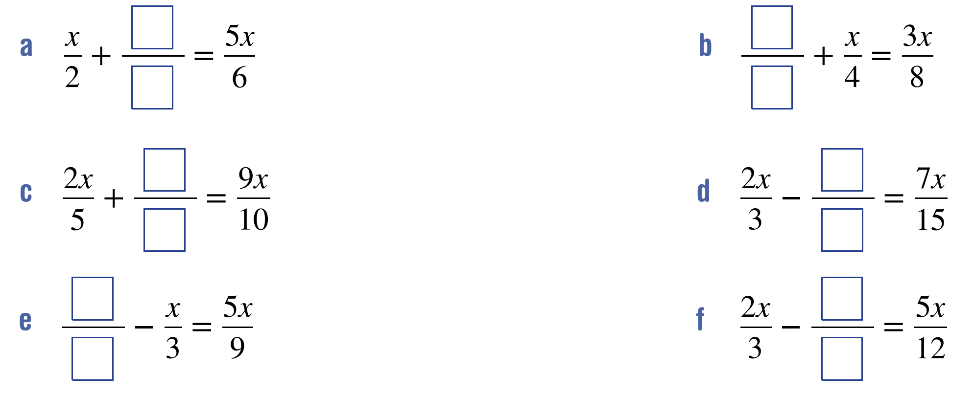  $$\frac{2x}{3}$$ | $$\frac{x}{8}$$ | $$\frac{x}{2}$$
$$\frac{x}{5}$$ | $$\frac{8x}{9}$$ | $$\frac{x}{4}$$

Multiplying Algebraic Fractions

- Review
- Simplify algebraic multiplication.
- $5×2m$ | - $3×6r$ | - $8×ab$
- $2×-7y$ | - $5×b$ | - $17y×3$

- Multiply fractions
$$\frac{2}{5}×\frac{1}{2}$$ | $$\frac{2}{5}×\frac{3}{4}$$ | $$\frac{3}{5}×\frac{6}{7}$$ | $$\frac{2}{3}×\frac{3}{5}×\frac{4}{7}$$

- Simplify fractions before multiplying
$$\frac{12}{18}×\frac{5}{7}$$ | $$\frac{8}{7}×\frac{7}{15}$$ | $$\frac{2}{5}×\frac{15}{24}$$ | $$\frac{8}{27}×\frac{9}{16}$$

- Simplify algebraic fractions
- $\frac{2x}{6}$ | - $\frac{5xy}{2y}$ | - $\frac{7ab}{14b}$ | - $\frac{2c}{5bc}$

- Multiplying Algebraic Fractions
To multiply fractions, multiply the numerators and multiply the denominators.
$$\frac{a}{b}×\frac{c}{d}=\frac{a×c}{b×d}$$

- Example Multiply algebraic fractions
$$\frac{2a}{5}×\frac{3b}{7}$$  $$=\frac{2a×3b}{5×7}$$  $$=\frac{6ab}{35}$$ | $$\frac{4x}{15}×\frac{3x}{2}$$  $$=\frac{4x×3x}{15×2}$$  $$=\frac{12x^{2}}{30}$$  $$=\frac{2x^{2}}{5}$$

- Guided Practice
Simplify.
- $\frac{x}{3}×\frac{2}{5}$  $$\frac{2x}{15}$$ | - $\frac{2}{3}×\frac{4a}{5}$  $$\frac{8a}{15}$$
- $\frac{6x}{5}×\frac{7y}{6}$  $$\frac{7xy}{5}$$ | - $\frac{8a}{5}×\frac{3b}{4a}$  $$\frac{6b}{5a}$$
- $\frac{3x}{2}×6$  $$9x$$ | - $\frac{10x}{3}×\frac{6x}{5x}$  $$4x$$

- Key Ideas
- To multiply algebraic fractions, we multiply the ……………… and multiply the ……………

Foundation
- Multiply these fractions.
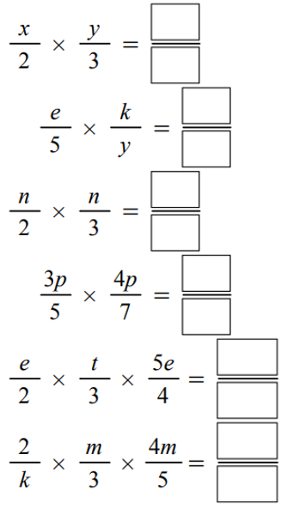  $$\frac{xy}{6}$$ | $$\frac{ek}{5y}$$ | $$\frac{n^{2}}{6}$$
$$\frac{12p^{2}}{35}$$ | $$\frac{5e^{2}t}{24}$$ | $$\frac{8m^{2}}{15k}$$

- Simplify these products.
- $\frac{x}{3}×\frac{2}{5}$  $$\frac{2x}{15}$$ | - $\frac{1}{7}×\frac{a}{9}$  $$\frac{a}{63}$$ | - $\frac{2}{3}×\frac{4a}{5}$  $$\frac{8a}{15}$$
- $\frac{4c}{5}×\frac{1}{5}$  $$\frac{4c}{25}$$ | - $\frac{4a}{3}×\frac{2b}{5}$  $$\frac{8ab}{15}$$ | - $\frac{3a}{2}×\frac{7a}{5}$  $$\frac{21a^{2}}{10}$$

- Multiply these fractions.
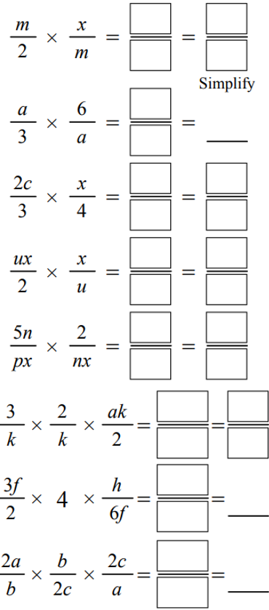  $$\frac{x}{2}$$ | $$2$$ | $$\frac{cx}{6}$$
$$\frac{x^{2}}{2}$$ | $$\frac{10}{px^{2}}$$ | $$\frac{3a}{k}$$
$$h$$ | $$2$$

- Simplify these products. Remember to simplify before you multiply.
- $\frac{6x}{5}×\frac{7y}{6}$  $$\frac{7xy}{5}$$ | - $\frac{2b}{5}×\frac{7d}{6}$  $$\frac{7bd}{15}$$ | - $\frac{8a}{5}×\frac{3b}{4c}$  $$\frac{6ab}{5c}$$
- $\frac{9d}{2}×\frac{4e}{7}$  $$\frac{18de}{7}$$ | - $\frac{3x}{2}×\frac{1}{6x}$  $$\frac{1}{4}$$ | - $\frac{4}{9k}×\frac{3k}{2}$  $$\frac{2}{3}$$

Development
- The width of a rectangle is $\frac{3x}{5}$ cm. Its length is four times its width.
Write an expression for the area of the rectangle.

$\frac{36x^{2}}{25}$ cm
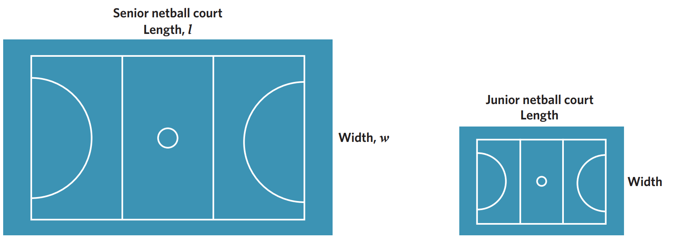
- The senior and junior netball courts have different dimensions.
The junior netball court has a length that is half of the senior netball court and a width that is two-thirds of the senior netball court.

  - Write an expression for the area of the senior netball court.
$$lw$$
  - Write an expression for the length and width of the junior netball court.
$$\frac{l}{2},\frac{2w}{3}$$
  - Write an expression for the area of the junior netball court.
$$\frac{lw}{3}$$
  - Write an expression for the difference between the senior netball court and the junior netball court.
$$\frac{2lw}{3}$$
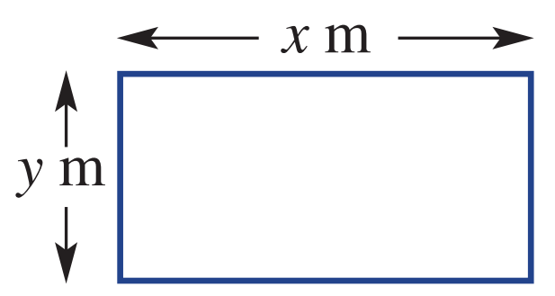
- The rectangular field below has length $x$ metres and breadth $y$ metres.
  - Write an expression for the area of the field.
$xy$
  - A smaller section is fenced off. It is $\frac{1}{2}$ the length and $\frac{3}{4}$ the breadth.
    - Write an expression for the length and breadth of the smaller section.
$$\frac{x}{2}, \frac{3y}{4}$$
    - Hence, write an expression for the area of the smaller section.
$$\frac{3xy}{8}$$
  - Find the percentage of the smaller area compared to the larger area.
$$37.5\%$$

Mastery
- Consider a square with side length $x$.
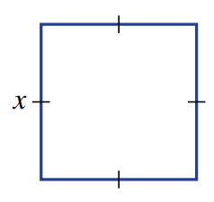
  - Write an expression for the area of the square.
$x^{2}$
  - The length of each side is now halved.
Give an expression for the area of the new square.
$\frac{x^{2}}{4}$
  - If each side of the original square is multiplied by 0.7, find an expression for the area of the square, as an algebraic fraction. Recall that $0.7=$ $\frac{7}{10}$

$$\frac{49x^{2}}{100}$$
  - If each side of the original square is three-fifths of the original length, would the new area be more or less than half of the original area? Show your reasoning.

The new area is $\frac{9x^{2}}{25}$, which is less than $\frac{1}{2}$ of $x^{2}$
  - If you want to halve the area of the original square, by what factor would you have to divide each length?

Divide by $\sqrt{2}$
  - If you continued to reduce each side of the original square by a factor of $\frac{3}{5}$,
show that the area after 2 reductions is $\frac{81}{625}x^{2}$

  - If you continued to reduce each side of the original square by a factor of $\frac{3}{5}$,
write an expression for the area after $n$ reductions.

$${\left(\frac{3}{5}\right)}^{2n}x^{2}$$

Dividing Algebraic Fractions

- Review
- Identify the reciprocal.
$$\frac{2}{3}$$ | $$\frac{7}{8}$$ | $$12$$ | $$\frac{1}{5x}$$
- Divide fractions.
$$\frac{2}{3}÷\frac{4}{5}$$ | $$\frac{1}{2}÷\frac{1}{4}$$ | $$\frac{3}{4}÷\frac{2}{5}$$ | $$\frac{1}{3}÷4$$

- Rule for Dividing Fractions
To divide by a fraction, multiply by the reciprocal.
$$=\frac{a}{b}÷\frac{c}{d} \\ =\frac{a}{b}×\frac{d}{c}$$

- Example Divide algebraic fractions
$$\frac{3a}{8}÷\frac{b}{5}$$  $$=\frac{3a}{8}×\frac{5}{b}$$  $$=\frac{15a}{8b}$$ | $$\frac{u}{4}÷\frac{15p}{2}$$  $$=\frac{u}{4}×\frac{2}{15p}$$  $$=\frac{2u}{60p}=\frac{u}{30p}$$

- Guided Practice
Simplify.
- $\frac{3a}{5}÷\frac{1}{5}$  $$3a$$ | - $\frac{9a}{10}÷\frac{1}{4}$  $$\frac{18a}{5}$$
- $\frac{4}{5}÷\frac{2y}{3}$  $$\frac{6}{5y}$$ | - $\frac{4a}{7}÷\frac{2}{5}$  $$\frac{10a}{7}$$
- $\frac{4x}{5}÷3$  $$\frac{4x}{15}$$ | - $2÷\frac{x}{5}$  $$\frac{10}{x}$$

- Key Ideas
- Dividing by a fraction is the same as multiplying by the ……………………

Foundation
- Divide these fractions.
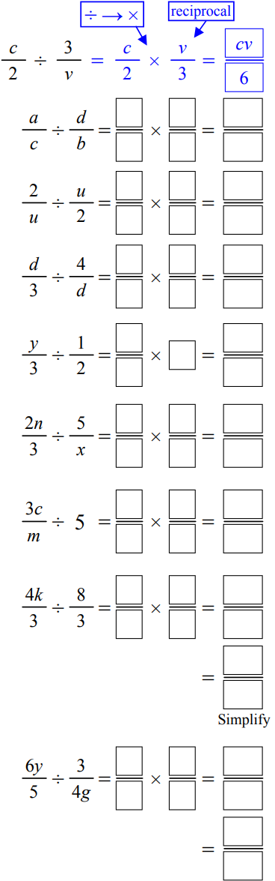 | $$\frac{ab}{cd}$$ | $$\frac{4}{u^{2}}$$
$$\frac{d^{2}}{12}$$ | $$\frac{2y}{3}$$ | $$\frac{2nx}{15}$$
$$\frac{3c}{5m}$$ | $$\frac{k}{2}$$ | $$\frac{8gy}{5}$$

- Simplify these divisions. Remember to simplify before you multiply.
- $\frac{2}{3}÷\frac{4x}{7}$  $$\frac{7}{6x}$$ | - $\frac{4}{5}÷\frac{2y}{3}$  $$\frac{6}{5y}$$ | - $\frac{1}{7}÷\frac{2}{x}$  $$\frac{x}{14}$$
- $\frac{4a}{7}÷\frac{2}{5}$  $$\frac{10x}{7}$$ | - $\frac{4b}{7}÷\frac{2c}{5}$  $$\frac{10}{7c}$$ | - $\frac{2x}{5}÷\frac{4y}{3}$  $$\frac{3}{10y}$$
- $\frac{2y}{x}÷\frac{3}{y}$  $$\frac{2y^{2}}{3x}$$ | - $\frac{5}{12x}÷\frac{7x}{2}$  $$\frac{5}{42x^{2}}$$ | - $\frac{4a}{5}÷\frac{2b}{7a}$  $$\frac{14a}{5b}$$

Development
- Simplify the following.
- $3×$ $\frac{4x}{5}$  $$\frac{12x}{5}$$ | - $\frac{4x}{5}÷$ $3$  $$\frac{4x}{15}$$ | - $2÷$ $\frac{x}{5}$  $$\frac{10}{x}$$
- $4×$ $\frac{a}{3}$  $$\frac{4a}{3}$$ | - $5×$ $\frac{7}{10x}$  $$\frac{7}{2x}$$ | - $1÷$ $\frac{x}{2}$  $$\frac{2}{x}$$

- Simplify these expressions. Only invert the fractions being divided.
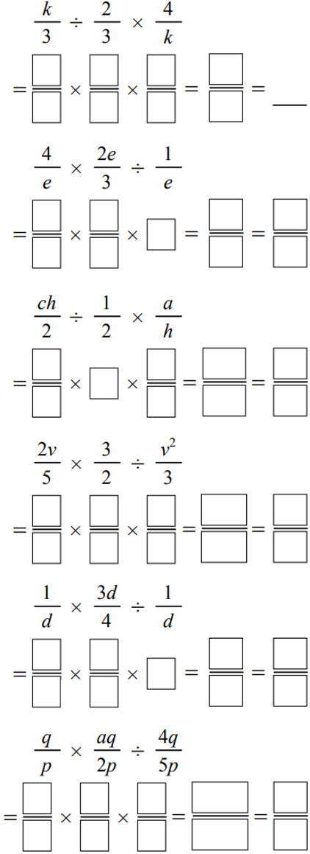  $$2$$ | $$\frac{8e}{3}$$ | $$ac$$
$$\frac{9}{5v}$$ | $$\frac{3d}{4}$$ | $$\frac{5aq}{8p}$$

- Krystal’s family goes to dinner with Helen’s family.
The bill comes to a total of $$x$ and each family pays half.
  - Write an algebraic fraction for the amount Krystal’s family pays.
$$\frac{x}{2}$$
  - Krystal says she will pay one third of her family’s bill.
Write an algebraic fraction for the amount that she pays.
$$\frac{x}{6}$$
- Write an algebraic fraction for the result of the following operations.
  - A number $q$ is halved and then the result is tripled.
$$\frac{3q}{2}$$
  - A number $x$ is multiplied by $\frac{2}{3}$ and the result is divided by $1\frac{1}{3}$.
$$\frac{x}{2}$$
  - A fraction $\frac{a}{b}$ is multiplied by its reciprocal.
1
  - The number $x$ is reduced by 25% and then halved.
$$\frac{3x}{8}$$

Mastery
- Simplify the expressions.
$$5mn×\frac{4d}{n}×\frac{1}{15mn}$$  $$\frac{3d}{3n}$$ | $$\frac{6}{r}×\frac{5r}{9}÷\frac{15}{xy}$$  $$\frac{2xy}{9}$$
$$\frac{6cf}{q}÷\frac{5}{qf}÷\frac{10c}{a}$$  $$\frac{3a}{25}$$ | $$\frac{4ab}{5}÷\frac{a}{2b}÷\frac{8b}{15}$$  $$3b$$

- Expand and simplify the following.
$$\frac{1}{2}\left(x+4\right)$$  $$\frac{x}{2}+2$$ | $$\frac{2}{3}\left(y-3\right)$$  $$\frac{2y}{3}-2$$ | $$\frac{3}{4}\left(2a+4b\right)$$  $$\frac{3a}{2}+3b$$
$$\frac{1}{2}\left(6x+8\right)+\frac{1}{3}\left(12x-3\right)$$  $$7x+3$$ | $$\frac{2}{3}\left(12y-6\right)+\frac{1}{4}\left(2y+3\right)$$  $$\frac{17y}{2}-\frac{13}{4}$$ | $$\frac{x}{3}\left(6+9y\right)+y\left(x+4\right)$$  $$2x+4xy+4y$$

